Record No: 0570
SIR HENRY JEBB
College of Surgeons Ireland, of Malborough St, Dublin.

Husband of Jane Somerville (0569).

Birth:
Marriage: Jane Somerville
Death:

Notes:

Source: Somerville Index.

Additional Research:
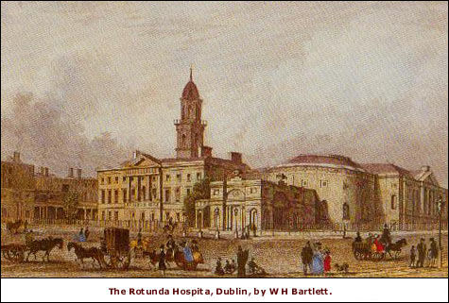
The Department of Obstetrics and Gynaecology at the Royal College of Surgeons in Ireland is one of the oldest on record, with an unbroken line of RCSI “Professors of Obstetrics and Gynaecology” (originally titled “Professors of Midwifery”) since 1770.

The discipline of obstetrics and gynaecology, arguably more than any other, has played the most major of roles in the Royal College of Surgeons in Ireland right from its very birth. The first general meeting of the College was held in the boardroom of the Rotunda Hospital on 2nd March 1784. Acknowledging that Surgeons throughout the ages practiced Midwifery, the College Charter of incorporation included a Licentiate of Midwifery. Since 1886 this has still continued to be earned by RCSI graduands as part of a conjoint diploma with the Royal College of Physicians of Ireland. In addition, since 1978, the BAO degree (Bachelor of the Art of Obstetrics) of the National University of Ireland is also awarded at undergraduate qualification.
Milestones over the past two hundred years in the RCSI Department of Obstetrics and Gynaecology include:

1785 | RCSI adopts resolution establishing “professorship of midwifery”
1789 | John Halahan, ex-assistant Master of the Rotunda becomes first RCSI Professor by introducing regular courses on midwifery
1793 | Henry Jebb, ex-assistant Master of the Rotunda replaces Halahan, and ultimately becomes President of the RCSI in 1800
www.rcsiwomenshealth.com/About_Us/History/index.asp

